:росток:Beet Seed

**BR#1**

Google Chrome 131.0.6778.205 (Official Build) (64-bit)

“Зворотній дзвінок” form freezes during fast input in the phone number field.

Preconditions:

1. Main page is open: <https://avtozvuk.ua/ua>

STR:

1. Navigate to page footer
2. Click on “Зворотній дзвінок” button
3. Enter numbers quickly into the field
4. Observe the form`s behavior

Expected result: The phone number field handles fast input without causing the form to freeze or become unresponsive.

Actual result: The form freezes when data is entered rapidly into the phone number field, making the form unresponsive.

Video link: <https://youtu.be/Syd1CWCLvcc>

Priority: Medium

Severity: Medium

**BR#2**

Google Chrome 131.0.6778.205 (Official Build) (64-bit)

Placeholder text for incomplete pages is not translated into Ukrainian

1. Main page is open: <https://avtozvuk.ua/ua>
2. Site language set to ukrainian

STR:

1. Navigate to insurance page: <https://avtozvuk.ua/ua/insurance>
2. Observe the placeholder text displayed on the page

Expected result: The placeholder text fully translated into Ukrainian when the site language set to ukrainian.

Actual result: The placeholder text appears in a different language.

Priority: Low

Severity: Low

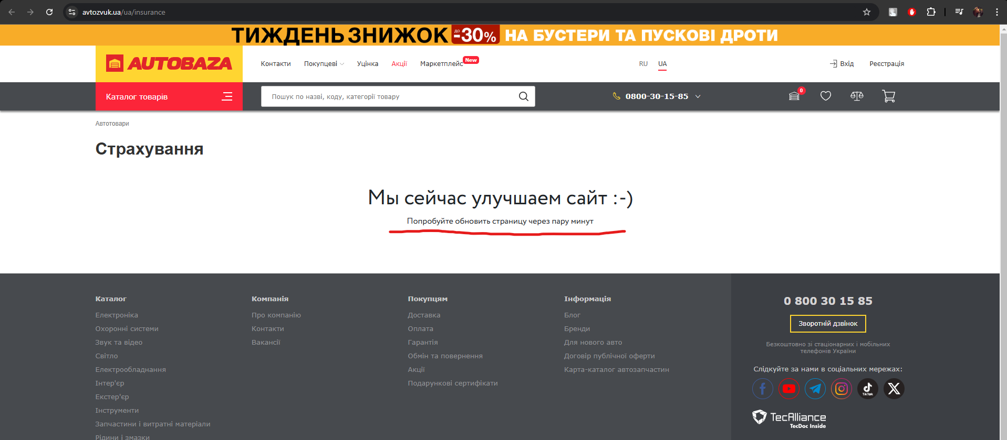

**BR#3**

Google Chrome 131.0.6778.205 (Official Build) (64-bit)

The "Ім’я" field in the subscription form for special offers does not accept Latin characters

Preconditions:

1. Main page is open: <https://avtozvuk.ua/ua>

STR:

1. Navigate to page footer
2. Fill the “Ім’я” form using Latin characters
3. Observe the form feedback

Expected result: The "Ім’я" field accepts input in Latin characters,

Actual result: The "Ім’я" field rejects Latin characters, preventing some users from completing the subscription

Priority: High

Severity: Low

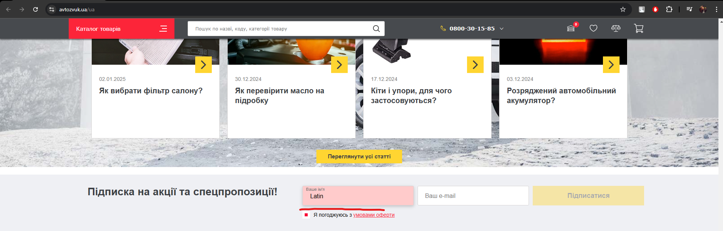

:травы: Beet Sprout

* [https://beetroot.academy](https://beetroot.academy/) UTF-8
* <https://microseniors76.com/> iso-8859-1
* <https://www.tennis-warehouse.com/> UTF-8
* <https://www.fidelity.com/> UTF-8